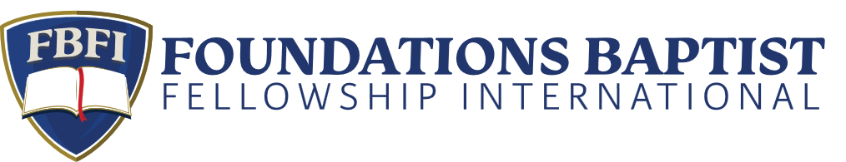

**Central Regional Fellowship**

Dear Friend,

Faith Baptist Church in Manhattan, Kansas is pleased to invite you to the next FBFI Central Regional Fellowship on October 21-22, 2024.  The theme this year is “Serving our Generation in Ministry” We are blessed to have Dr. Mark Minnick and Dr. Bruce McAllister as speakers.  The conference schedule will be as follows:

**MONDAY**

**1:00 p.m.        Registration**

**1:30 p.m.        Mark Minnick**

**3:00 p.m. Introductions and Testimonies**

**5:00 p.m.        Free Time - Dinner at our Church**

**7:00 p.m.        Bruce McAllister**

***Dessert Fellowship following the Service***

**TUESDAY**

**8:00 a.m.        Continental Breakfast**

**9:00 a.m. Bruce McAllister**

**10:30 a.m. Mark Minnick**

**12:15 p.m.      Lunch at Church**

**1:30 p.m.        Bruce McAllister**

**3:00 p.m. *Split Session***

**Men: Panel Discussion with Mark Minnick and Bruce McAllister on Contemporary Issues**

**Ladies: Anne Byford and Karis Herbster**

**5:00 p.m.         Free Time - Dinner at our Church**

**7:00 p.m.         Mark Minnick**

There is no fee for the Conference but we will be taking love offerings in the evenings to help cover the costs. In the past, some pastors brought an offering from their church. This is a real help. There are several hotels in Manhattan as well as Junction City. Most hotels are within 15 minutes of our church. If you reserve a room soon, you might get a good deal online. Pastor Nathan Herbster will be reaching out to some of you regarding special music.

Please feel free to share this information with others in your church. Also, if you know of another pastor or family that might be interested in this conference, please pass this information along to them.

We do ask that you RSVP for the fellowship by September 30th so that we can plan accordingly.  Please e-mail, call or text me to enable us to get an approximate number for the lunch and refreshments. [faithkansas@juno.com](http://webmaila.juno.com/webmail/new/8?folder=Inbox&msgNum=0000Adk0:001EF70o00002jZX&block=1&msgNature=all&msgStatus=all&count=1312602169&randid=1544388868&content=central) (785) 564-1279. We would like the names of all those attending in your family/church. Nursery will be provided for both of the evening services for 3 years and under. We at Faith Baptist Church truly hope you can make it to our fellowship.

See you in October,

Pastor Dave Byford